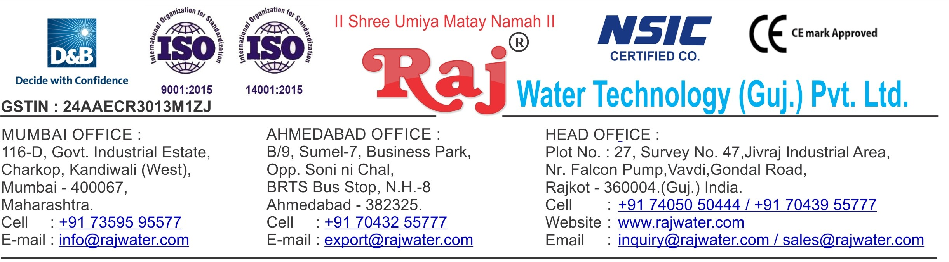

|  |  |  |  |
| --- | --- | --- | --- |
|  | | | Date :- 9th May 2019  Thursday |
| Quotation No | :- | RW/2019-20/Q_1597/R_5 |  |
| Concern Person | :- | Mr. Chandrashekhar Bauskar |  |
| Concern Number | :- | 9428511032 |  |
| Email Id | :- | [cedauskar@gamil.com](mailto:cedauskar@gamil.com) |  |
| Company Name | :- | GAIL (INDIA ) Limited |  |
| Address | :- |  |  |

# Quotation For Water Treatment Project

## Dear Sir ,

We are pleased to enclose our detailed Techno-Commercial offer, based on your requirement.

**Contents of the Quotation** Commercial Proposal Terms & Condition

Technical Specification for each product

## Machinery Offer

Water Treatment Project

We hope the same is in line with your requirement. We shall gladly assist you in case you need any further clarification or information.

With warm Regards,

## For , Raj Water Technology (Guj.) Pvt. Ltd.

**DESHANI KHUSHBU**

**Designation : Marketing Asst. Manager Mobile : 7405050222**

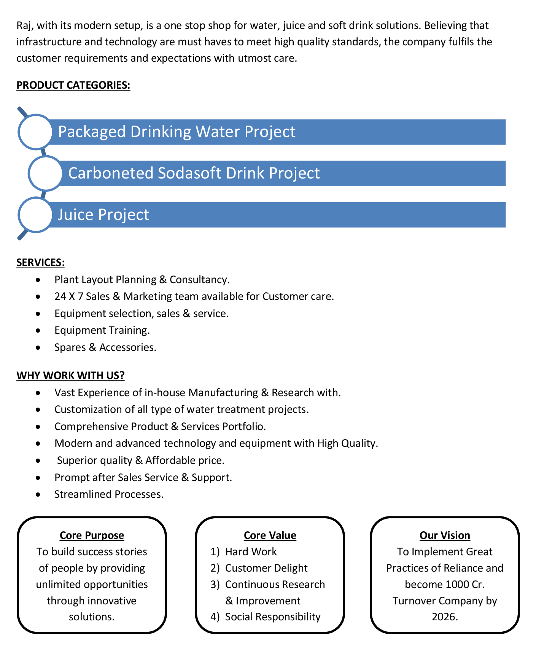



|  |  |  |  |  |
| --- | --- | --- | --- | --- |
| **Sr No.** | **Equipment Name** | **Qty** | **Basic Rate** | **Amount** |
| 1 | Reverse Osmosis Plant 85 M3/HR Complete With R.O Membrane Cleaning System Piping And SS Skid | 1 | 11000000.00 | 11000000.00 |
|  |  |  |  |  |
| **Total Amount in Words :-**  One Hundred Ten Lakh | | | **Total Amount** | **1,10,00,000.00** |

1. **Price**

The Quoted Prices Are Ex-factory. (For India) The Quoted Prices Are FOB. (For Export)

1. **TAX**

GST 18% Extra Applicable. (For India)

1. **Payment**

50% Advance Along With The Purchase Order, 30% After Inspection, & 20% Before Material Dispatch.

In Case Of Cancellation Of Confirmed Order Due To Any Reason, As A Part Of Penalty 25% Amount Of The Order Value Shall Have To Pay By You To Raj Water.

1. **Packing, Freight & Transit Insurance, & Unloading**

Packing Charge Will Be Extra (Depend On Packing Material)

Transport To Be Arranged By The Customer OR If Arranged By Raj Water: Extra At Actual Plus GST. Transportation Insurance In The Scope Of Buyer.

Unloading In The Scope Of Buyer. Buyer Has To Ready Forklift Or Crane And Unskilled Labor.

1. **Delivery**

Schedule For Dispatch Will Be Notified.

Delivery Dates Are Approximate Only, And Assume Timely Receipt Of All Information, Test Materials & Payment.

1. **Warranty**

We Shall Provide 1 Year Warranty For The Following:

Manufacturing Defects, Raw Water Pump, High Pressure Pump, Treated Water Transfer Pump.

Due To Fluctuation In Power Supply, Attempted Repaired By Person Other Than Our Technical Representative, Improper Handling Or Negligence By End Users, Poor Maintenance, Improper Use Of Equipment, That All Type Of Damage Not Covered In Warranty Create Area.

During The Warranty Period, We Shall Provide Supervisory Services Of Our Technical Representative As And When Required.

1. **Accommodation**

Technician Charge Will Be Extra 1000/- Rs. Per Day.

Travelling, Lodging And Boarding, Local Conveyance And Any Other Miscellaneous Expense Of Our Technical Representative Will Have To Be Borne By Client.

1. **Validity**

Our Offer Is Valid For Your Acceptance For A Period Of 6 Months From The Date; Thereafter It Will Be Subject To Confirmation By Us.

1. **Image**

Images Are For Representation Purpose Only.

1. **Jurisdiction**

All Terms Subject To Rajkot, Gujarat Jurisdiction.

# Technical Specification

## Raw Water Quality

R.O. plant is designed based On :

8902 TDS

Hardness : 3680

### Application :-

1. **Treated Water Quality**

Suspended Solids : Nill Turbidity : Nill

PH : 7.0 To 7.5

T D S : 100ppm

Total Hardness : -

Bacteria Coliform : Nill

### Application :-

The above water quality is approximate assumption, We can change property of minerals/ions in water by editing the raw water in R.O. treated water

Type : Centrifugal

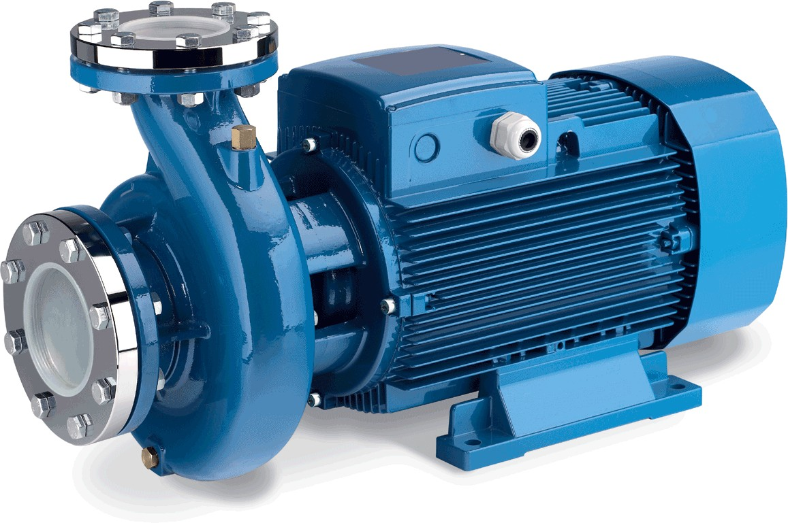Working Flow : 130.00 m3/HR

Working Pressure : 2 Kg. / Cm 2

M.O.C. : C.I.

Power : 20.0 HP

Manufacturer : Grundfoss

Nos. Offered : 1 Nos.

### Application :-

To Pump Raw Water at Required Pressure so as to enable Transfer Through The RO Pre-Treatment Stage.

## 4. Pressure Sand Filter (MS)

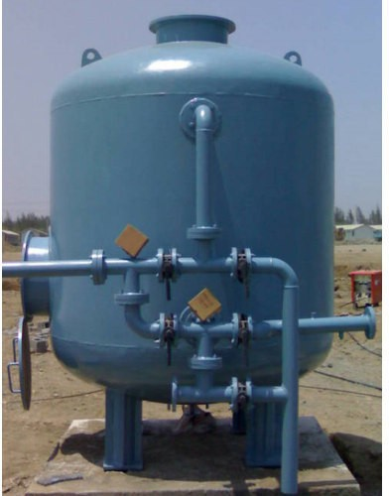Type : Down Flow Graded Sand Type

Model : 100120/RW/MFG

M.O.C. : MS

Size Dia X Height : 2500 mm X 3000 mm Pipe Line Size : 125 mm.

Sand Qty. : 16000 Kgs.

Valves : Butterfly Valve

Working Flow : 130.00 m3/HR

Type : Down Flow Graded Sand Type

Model : 100120/RW/MFG

M.O.C. : MS

Size Dia X Height : 2500 mm X 3000 mm Pipe Line Size : 125 mm

Carbon Qty. : 6500Kgs.

Valves : Butterfly Valve

Working Flow : 130.00 m3/HR

## 6. Micron Cartridge Filter Housing (4 Nos)

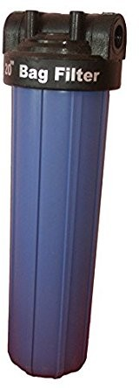Model : MCF 30/RW/PP

Size : 30" Long

Micron Rating : 5 Micron

Type of Candle : P. P. Spun / Wound Material of Housing : PP

Nos. of Candles : 24 nos

Working Flow : 130.00 m3/HR

### Application :-

To protect the membrane and the high pressure pump from suspended particles by removing them up to 5 Micron.

**7. Antiscalant Dosing Pump (4Nos)**

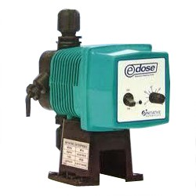Type : Ele. Diaphragm Type

Capacity : 0 to 25LPH

M.O.C. : PP

Dosing Chemical : Antiscalent Dosing Rate : 3 to 4 LPH

Make : E Dose/ I Dose

Nos : 4 Nos

### Application :-

The hardness salts of calcium & magnesium are likely to be precipitated if concentration exceeds its solubility limit & it may faults the membranes resulting into scaling which ultimately leads to poor treated water quality from R.O.System.

## 8. Antiscaling Dosing Tank(4Nos)

Type : Conical Bottom

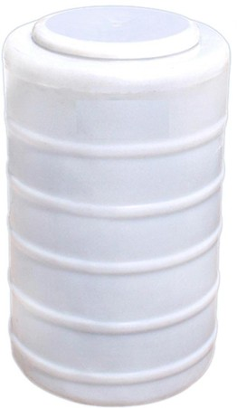Capacity : 200 Ltr.

M.O.C. : HDPE

Manufacturer : Reputed

Nos : 4 Nos

Type : Vertical Centrifugal Pump

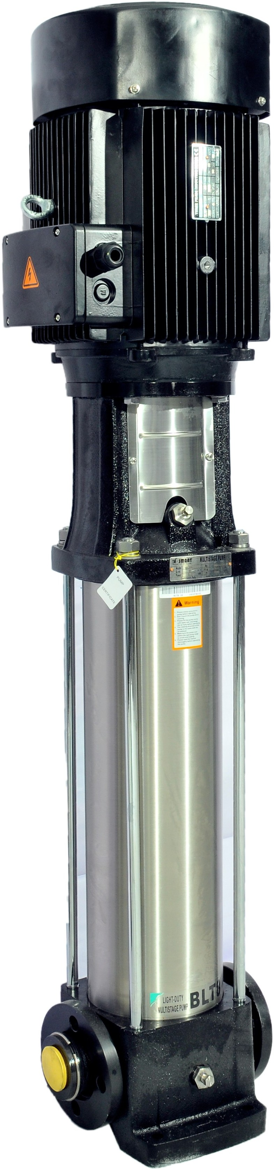M.O.C. : SS

Max. Pressure : 35 Kgs. / Cm 2. Working Pressure : 32 Kgs. / Cm 2.

Working Flow : 130.00 m3/HR

Motor : 110KW/37 KW

Manufacturer : 2900 RPM

Nos. Offered : 3 Phase

Make of Pump : Grundfoss

Nos. Offered : 2

### Application :-

For Reverse Osmosis Process to take place feed pressure of water need to be raised. For this purpose a Vertical Multistage Centrifugal High Pressure Pump in S.S construction is provided R.O. System requires operating pressure of about 14-16 kg/cm^2 . High-pressure pump is fitted with S.S. discharge pipe work with necessary control valves. Necessary instruments like a High Pressure Switch, Pressure Gauge and recirculation valves are provided for safer operation of system

## 10. RO Membrane

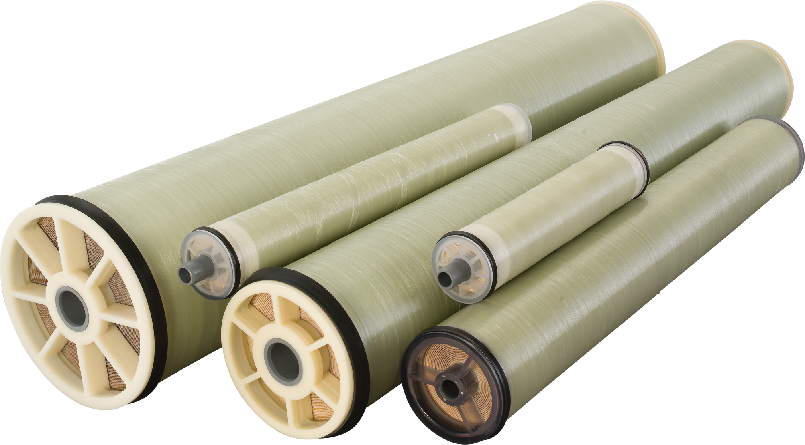Model : 8040 Element

Type : TFC Spiral Wound

Material : Polymide

Size : 8" Dia X 40" Long

Manufacturer : Toray

Nos. Offered : 84 Nos.

### Application :-

To reduce Raw Water T.D.S. through the concept of Reverse Osmosis where R.O. Modules processes Raw Water and produces Purified Water having the Salt Rejection of Raw Water in the range of 90 – 95%. By using Semi permeable Membrane filter elements, where ion filtration process is carried out by applying pressure in the water. So finally we will get Low salt water with low total dissolve solids and High purity. Here will have to drain the water at one side to Wash the Membrane filter elements continuously because of filtration process there is nothing to be polluted in the system.



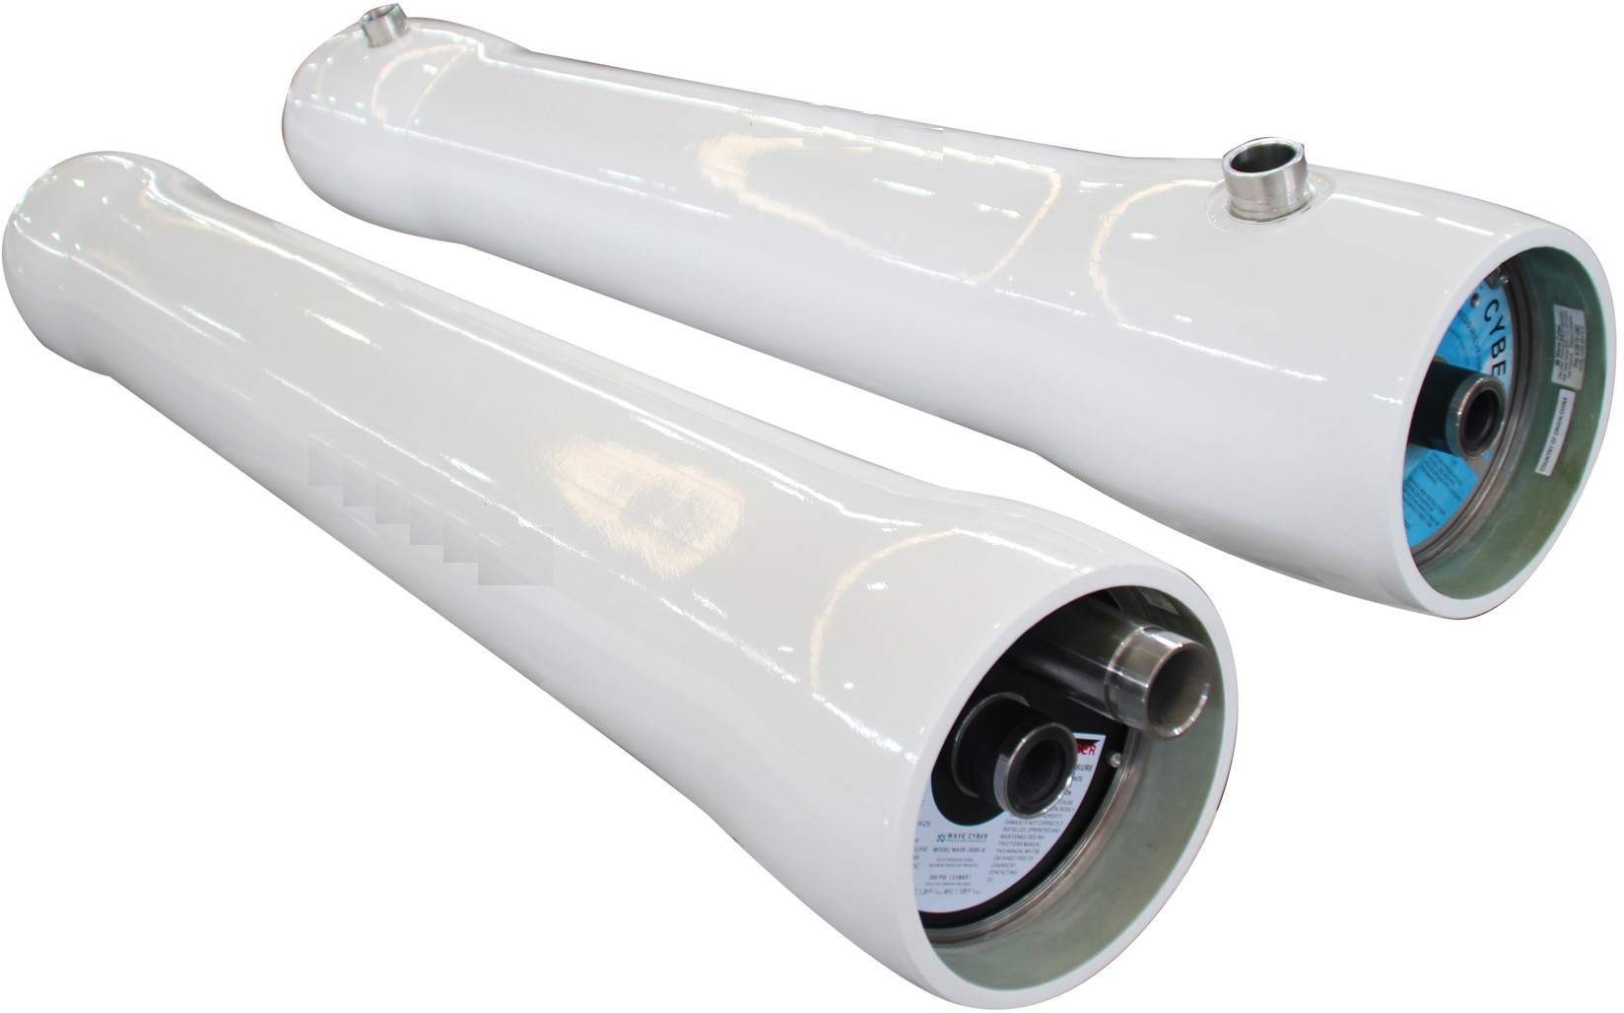M.O.C. : FRP

Type : Horizontal Tube Type

Size : 8" X 240"

Max. Pressure : 250 PSI Working Pressure : 150 PSI Nos. Offered : 14 Nos.

## 12. RO Membrane Cleaning Tank

Working Flow : Centrifugal

Working Flow : 2000 Ltr

M.O.C : HDPE

Model : Centrifugal Multi Stage

Working flow : 90.00 m3/HR Working pressure : 2.0 Kg/Cm2 Power : 10.H.P./2900 RPM

Make : Grundfoss

Nos : 1 Nos.

## 14. RO Membrane Cleaning Filter(3Nos)

Model : MCF 30/RW/PP

Size : 30” Long

Micron Rating : 5 Micron

Type of Candle : P.P. Spun Material Of Housing : PP

Nos. of Candles : 9 Nos.

Working Flow : 90.00 m3/HR

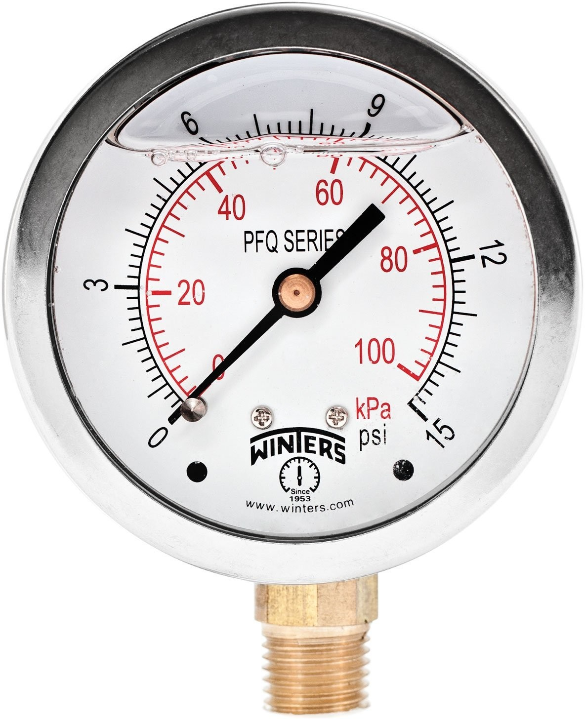Pressure Gauges : 4 Nos.

Type : Burdone Tube Type

Make : Raj

Range : 0 - 28 , 0 - 7 Kg/cm2

## 16. Online Rota Meters

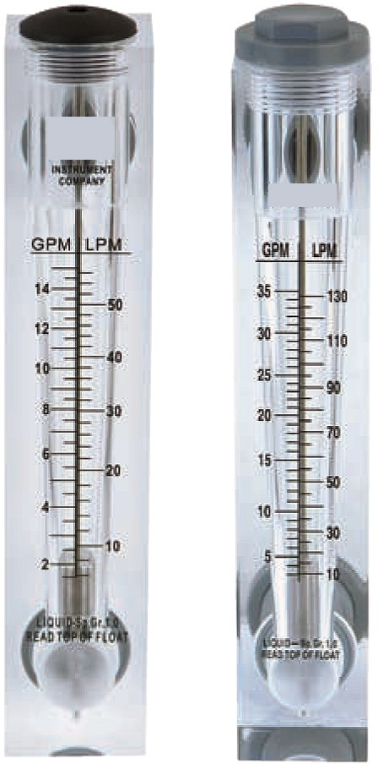Rota Meters : 2 Nos.

Type : Float

M.O.C. : Acrylic Body

Reject Water Range : SS Float (0 - 125000 Lph.)

Treated Water Range

:

SS Float (0 - 90000 Lph.)

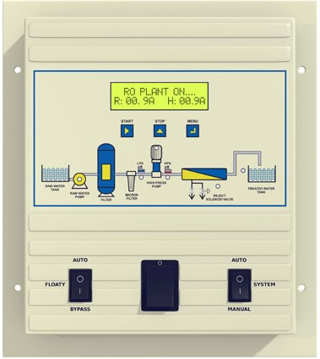Make : Astral

## 18. Pressure Switch

Pressure Switch : 2 Nos.

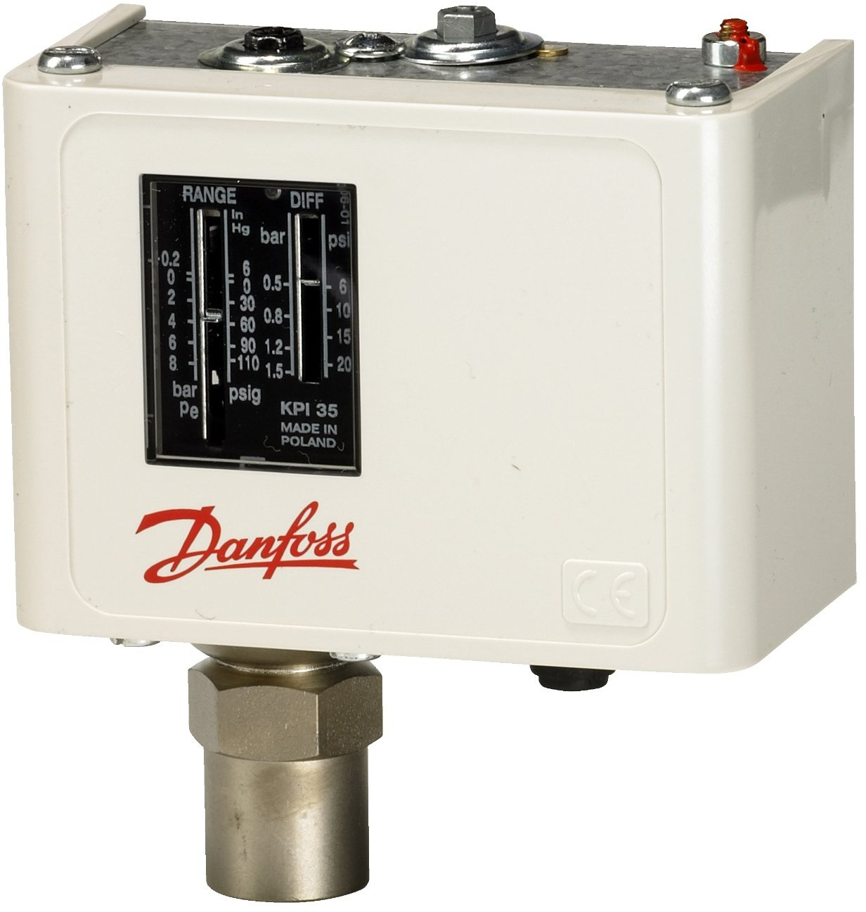Type : Low / High Pr.

Make : Denfoss

Model : IPS 70 / 400

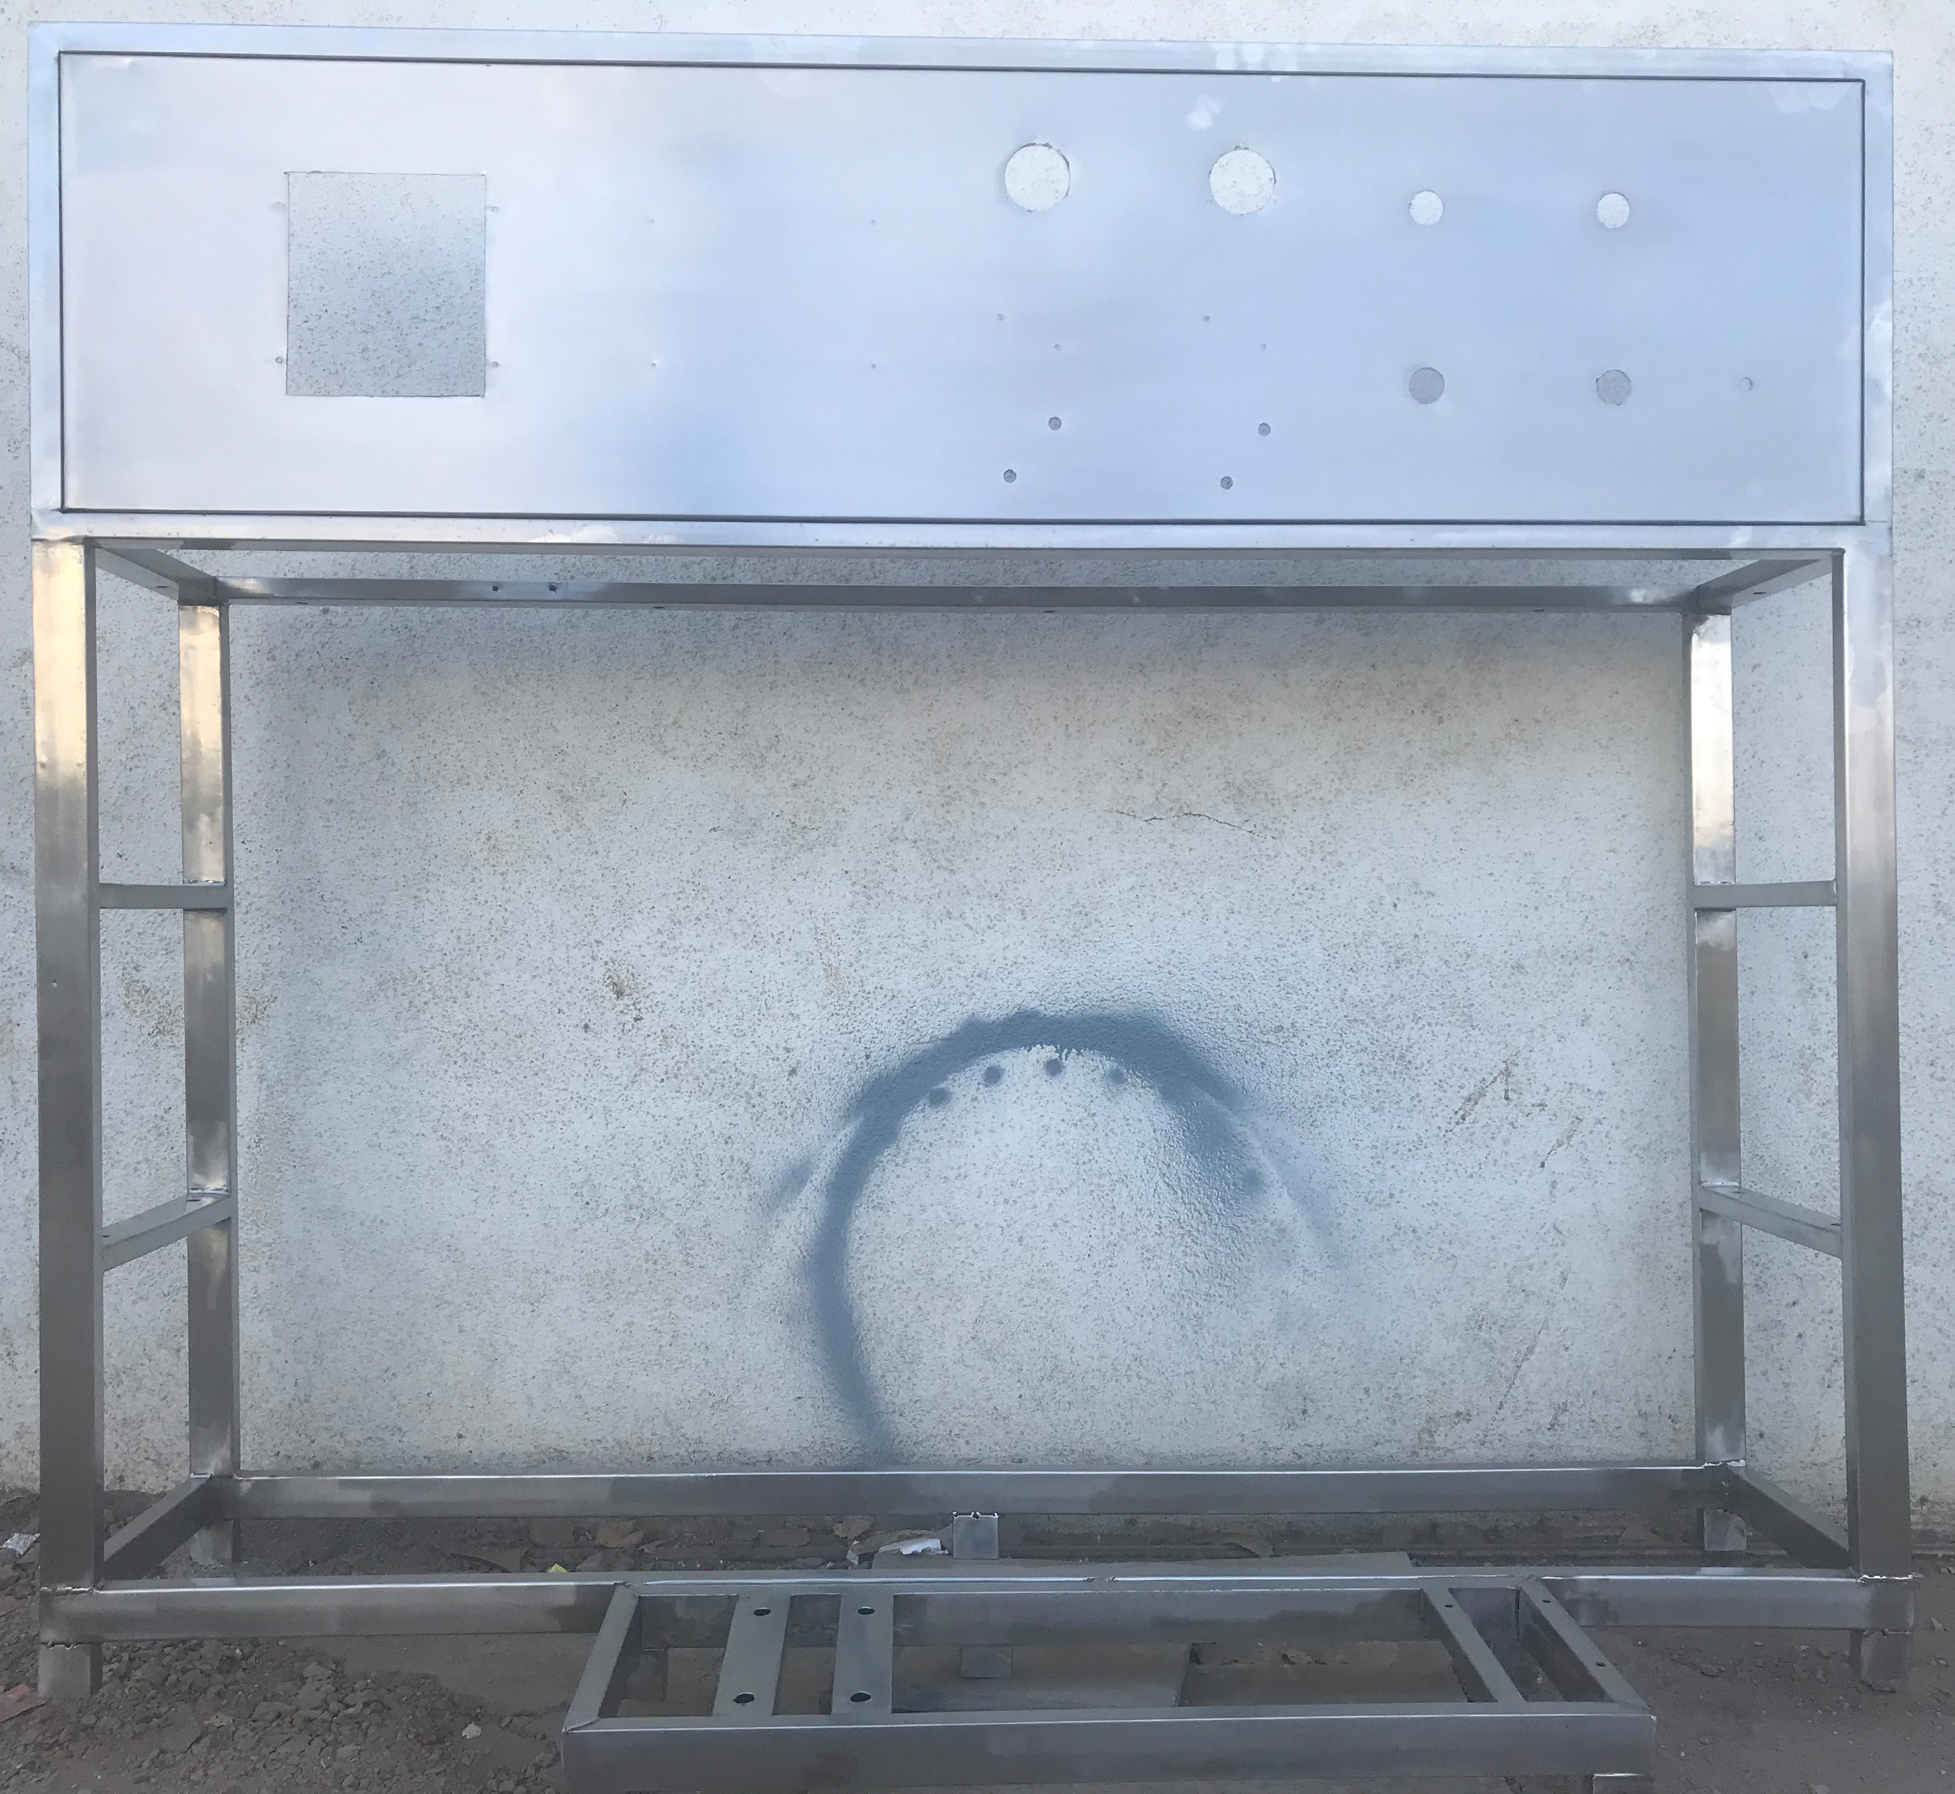Stainless Steel : S.S 304

### Application :-

Complete stand for unit will be made of S.S.304

## 20. UPVC Interconnecting Pipe Lines

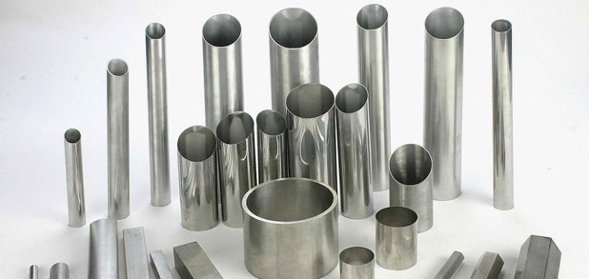

Interconnecting Pipe Lines :

### Application :-

MS/SS

All interconnecting Piping Raw Water Pump To RO will be provided of MS/SS by us.